Culture Exploration Magazine
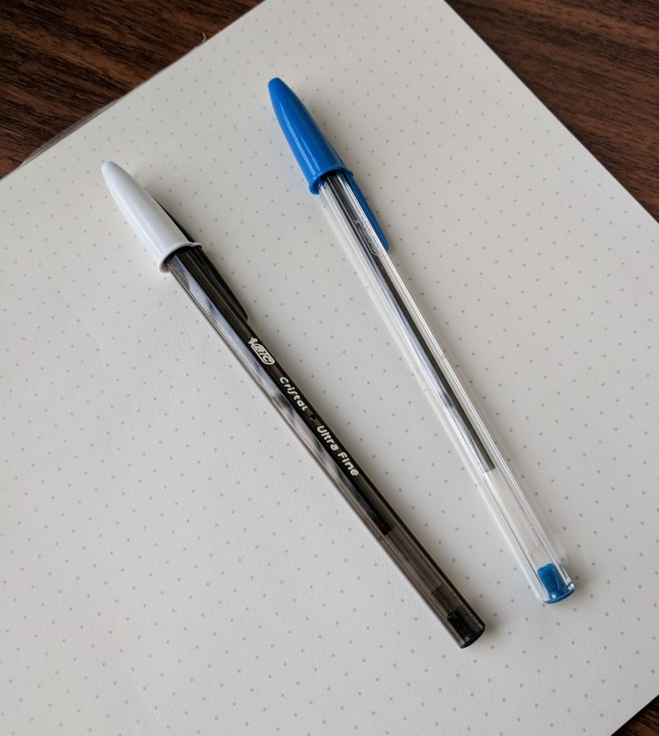

Introduction
The human race has gone through various evolutionary changes throughout history, developing incredible and ground-breaking discoveries that were aimed at making life better during specific historical times. Based on histography, different ages are categorized based on the complexity of materials used to make tools and equipment(Cunningham, 2018). For instance, the period occurring approximately two thousand years ago is usually referred to as the steel age, since most tools and equipment during that period were made using steel, iron, or bronze. This age later gave way to carbon fiber age, which was the later generation. During this period, petroleum products were predominantly used as sources of fuel, with hydro and solar power as the co-sources of energy, following the abandonment of coal as the source of power (Guido, Wieneke, & During, 2016). These petroleum products were also used as raw materials for the manufacture of other tools used during this age, including the current discovery.
As an explorer, the said period has sparked great curiosity, considering the considerable sophistication displayed by individuals living in that age. In a personal exploration of the area surrounding the Persian Gulf, and between what used to be the Tigris and Euphrates rivers, I came across a peculiar object, which I believe dates back two thousand years ago to the iron and petroleum ages (Cunningham, 2018). The area is believed to be rich in human history, with historical sites like Sumer, the site for the earliest known civilization, being within the region. While on the exploration mission in the area, we came across fragments of an object that was seemingly made of plastic, another material that was characterizing the steel and petroleum ages (Cunningham, 2018). The discovery prompted further digging, and after exploring several places for a couple of days, we came across the object. Though it cracked and broken, we believe most of its parts were found. Further digging in the area unraveled additional pieces which we believe are parts of other objects of a similar kind.
Object Description
The object has unique features which give an impression of what it may have been used for in the said historical period. The object comprises of three components, one of these beinga blue plastic cap, which we found to be 0.0345 Ounces with a smooth texture, and is a separate object (Ohio State University, 2020). The other component is a polystyrene barrel, which is blue, measures 5.83 inches in length with an internal diameter of 0.51 inches, and weighs approximately 0.35 ounces and is prone to brittle cracking when put under pressure. The third component is a small polypropylene tube, which is installed within the barrel and is connected to a brass tip with a tungsten carbide ballpoint (Ohio State University, 2020).Laboratory investigation of traces of a fluid found within the tube identified traces of gel ink made from a dye that is fully dissolved in an oil-based paste. Traces of pigment were also identified in the sample collected. These materials were easily and cheaply obtained during the steel and petroleum ages, as they were created as by-products in the manufacture of steel and processing of petroleum products (Guido, Wieneke,& During, 2016).
Generally, the object provides a smooth, silky feel to the touch, despite having scratched by the piles of dirt it has accumulated over the centuries(Ohio State University, 2020). The object is also engraved with the words BiCand Made in France, suggesting it to be a product made by a specific brand of the said age. Based on these words, we conducted historical investigations and discovered that BiCwas a manufacturing corporation that was based in France and specialized in the manufacture of inexpensive, disposable, polystyrene products, which include lighters, razors and pens (Poggi et al., 2017).The corporation’s products were widely used throughout the world, as statistical data indicates, meaning the object was in common use during this particular age in history. Additionally, since the corporate’s products were generally inexpensive, individuals from all walks of life, the rich, poor, or middle-class, must have had easy access to the product.
Object’s Alternative Function
The Cristal design characterizing theobjectand its lightweight are an indicator that it was a simple hand tool commonly used for simple chores. Furthermore, the traces of ink and pigments found within the tube second the idea that the object must have been used for writing purposes. During the petroleum and steel ages, most of the information was recorded and stored in paper form, with ball pens commonly used to record this information (Cunningham, 2018). Therefore, this object must have been used as a pen for recording information. The hexagonal barrel has a hazy blue color, which matches the bluecolor of the cap, meaning that the ink in this particular pen must have been blue, which was the color used for official handwritten documents during the specific ages. Therefore, this specific pen must have been used by individuals on an official basis (Gentleman Stationer, 2017).
Since most information was recorded through pen and paper during this age, individuals must have been doing a lot of writing daily. Therefore, the pen’s hexagonal barrel was designed with specific features for helping to reduce hand fatigue. These features include the smooth touch, which helps to reduce friction between the pen and the writer’s fingers, the oil-based ink, which was bound to make writing smooth, requiring relatively less pressure and effort and leaving a visibly bold line (Gentleman Stationer, 2017). Additionally, the BiCbrand name engraved on the barrel side was a ‘mark of quality’ during the steel and petroleum ages, making it a commonly used product for official use. The various tip sizes were used to provide different thicknesses, while the barrel cover prevented the ink from blobbing and smearing over pages and in the user’s pockets, creating messes (Gentleman Stationer, 2017).
Culture
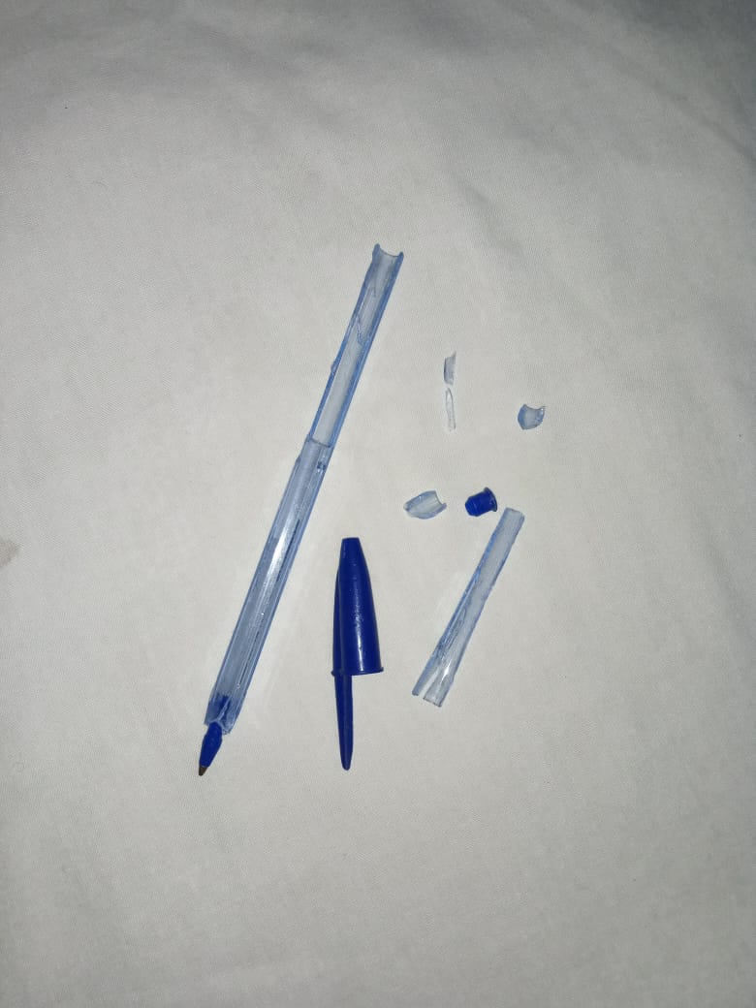
An investigation into the historical use of the item reveals that everyone commonly used it within the community since its design was meant to meet the needs of all individuals. The BiCCristal pen was designed to meet official, casual, personal, and educational requirements for its users at the particular time, setting the stage for a global and wide-spread application (Gentleman Stationer, 2017). For the academicians, handwriting was among the paramount, and the smooth writing feels generated by the pen facilitate this. Additionally, it was generally presentable, meaning individuals could use the item in their official purposes. The blue shade, characterizing the item discovered, was the standard for use in all official purposes (Gentleman Stationer, 2017).
Furthermore, the object was generally cheap, meaning and individuals from all walks of life had easy access to it and with the utmost convenience. They did not require many resources to acquire it (Gentleman Stationer, 2017). Furthermore, Société Bic of Clichy, the corporation that used to manufacture this object, runs numerous programs that aimed to make the object available for all individuals in the community. In doing so, all community members, regardless of their socioeconomic class, were associated with the object (Editorial, 2015).
During the steel and petroleum ages, stationery was essential for education and information storage. Therefore, numerouscorporations ventured into mass production for these products, Société Bic of Clichy being among these corporations, to meet the increasing demands (Guido, Wieneke,& During, 2016). The results were large-scale production of stationery, particularly pens. These individuals particularly preferred the BiC pen due to their varied advantages over the other similar products in the market (Editorial, 2015).

References
Cunningham, G. (2018). History & Histography. Scientific e-Resources.
Editorial. (, 2015). BIC'tween us. The BiC yearly magazine. Retrieved from https://www.bicworld.com/BIC-Annual-Report-2014/data/document.pdf.
Gentleman Stationer.(, 2017). The Bic Cristal Is (Arguably) The Greatest Pen Ever Made. [online] The Gentleman Stationer. Retrieved fromhttps://www.gentlemanstationer.com/blog/2017/12/13/the-bic-cristal-is-arguably-the-greatest-pen-ever-made
Guido, D., Wieneke, L., & During, M. (2016). histograph. Graph-based exploration, crowdsourced indexation. CVCE.
Ohio State University (2020). BiC Crystal Pens: The world’s most popular pen. Retrieved from https://u.osu.edu/bicpens/02-raw-materials/
Poggi, G., Giorgi, R., Mirabile, A., Xing, H., & Baglioni, P. (2017). A stabilizer-free non-polar dispersion for the deacidification of contemporary art on paper. Journal of Cultural Heritage, 26, 44-52.

